**Pre-treatment predictors of post-treatment fatigue at 2 years**

**Sample size**

In the original dataset, there were 270 patients. Out of the 270 patients, 206 patients had cancer treatment of chemotherapy and/or radiation. Out of the 206 patients, 194 patients had valid input of the outcome variable post-treatment SF-36 Vitality Score.

**Descriptive Statistics**

* Categorical Predictors in Number (%)

|  |  |  |  |  |
| --- | --- | --- | --- | --- |
| **Sample Characteristics** | **Overall (N = 194)**  **(Column %)** | **Fatigue (N = 86)**  **(Row %)** | **Not Fatigue (N = 108)**  **(Row %)** | **Bivariate p-value** |
| ***SF-vitality score (Baseline)*** |  |  |  | 5.49e-09** |
| Fatigue (<=45) | 63 (32.5%) | 48 (76.2%) | 15 (23.8%) |  |
| Not fatigue (>45) | 131 (67.5%) | 38 (29.0%) | 93 (71.0%) |  |
| ***BMI (Baseline)*** |  |  |  | 0.27 |
| Underweight (<18.5) | 9 (4.6%) | 6 (66.7%) | 3 (33.3%) |  |
| Normal (18.5 - 24.9) | 99 (51.0%) | 41 (41.4%) | 48 (57.6%) |  |
| Overweight (25.0 - 29.9) | 44 (22.7%) | 23 (52.3%) | 21 (47.7%) |  |
| Obese (>= 30.0) | 42 (21.6%) | 16 (38.1%) | 26 (61.9%) |  |
| ***Race*** |  |  |  | 0.75 |
| White | 133 (68.6%) | 60 (45.1%) | 73 (54.9%) |  |
| Non-White | 61 (31.4%) | 26 (42.6%) | 35 (57.4%) |  |
| ***Education*** |  |  |  | 0.40 |
| At most a high school degree | 54 (27.8%) | 27 (50.0%) | 27 (50.0%) |  |
| College graduate | 79 (40.7%) | 36 (45.6%) | 43 (54.4%) |  |
| Post-graduate degree | 61 (31.4%) | 23 (37.7%) | 38 (62.3%) |  |
| ***Employment*** |  |  |  | 0.02* |
| Yes | 122 (62.9%) | 46 (37.7%) | 76 (62.3%) |  |
| No | 72 (37.1%) | 40 (55.6%) | 32 (44.4%) |  |
| ***Married*** |  |  |  | 0.97 |
| Yes | 126 (64.9%) | 56 (44.4%) | 70 (55.6%) |  |
| No | 68 (35.1%) | 30 (44.1%) | 38 (55.9%) |  |
| ***Surgery Type*** |  |  |  | 0.45 |
| Lumpectomy | 145 (74.7%) | 62 (42.8%) | 83 (57.2%) |  |
| Mastectomy | 49 (25.3%) | 24 (49.0%) | 25 (51.0%) |  |
| ***Cancer treatment received*** |  |  |  | 0.36 |
| Chemo only | 19 (9.8%) | 9 (47.4%) | 10 (52.6%) |  |
| Radiation only | 108 (55.7%) | 52 (48.1%) | 56 (51.9%) |  |
| Chemo + radiation | 67 (34.5%) | 25 (37.3%) | 42 (62.7%) |  |
| ***CTQ: Childhood trauma*** |  |  |  | 0.08 |
| No childhood maltreatment | 126 (64.9%) | 50 (39.7%) | 76 (60.3%) |  |
| Any maltreatment | 68 (35.1%) | 36 (52.9%) | 32 (47.1%) |  |
| ***Attachment - baseline (SPS)*** |  |  |  | 0.0023** |
| <16 | 59 (30.4%) | 36 (61.0%) | 23 (39.0%) |  |
| 16 | 135 (60.6%) | 50 (37.0%) | 85 (63.0%) |  |
| ***Prior history of depression*** |  |  |  | 0.02* |
| Yes | 39 (20.1%) | 24 (61.5%) | 15 (38.5%) |  |
| No | 152 (78.4%) | 62 (40.8%) | 90 (59.2%) |  |
| Missing | 3 (1.5%) | 0 (0.0%) | 3 (100.0%) |  |
| ***SNPs – TNF high alleles*** |  |  |  | 0.06 |
| 2 | 110 (56.7%) | 43 (39.1%) | 67 (60.9%) |  |
| 0/1 | 31 (16.0%) | 18 (58.1%) | 13 (40.9%) |  |
| Missing | 53 (27.3%) | 25 (47.2%) | 28 (52.8%) |  |
| ***SNPs – IL6 high alleles*** |  |  |  | 0.560 |
| 2 | 71 (36.6%) | 29 (40.8%) | 42 (59.2%) |  |
| 0/1 | 70 (36.1%) | 32 (45.7%) | 38 (54.3%) |  |
| Missing | 53 (27.3%) | 25 (47.2%) | 28 (52.8%) |  |
| ***SNPs – IL1B high alleles*** |  |  |  | 0.778 |
| 2/1 | 126 (64.9%) | 54 (42.9%) | 72 (57.1%) |  |
| 0 | 15 (7.7%) | 7 (46.7%) | 8 (53.3%) |  |
| Missing | 53 (27.3%) | 25 (47.2%) | 28 (52.8%) |  |

* Continuous Predictors in Mean ± standard deviation

|  |  |  |  |  |
| --- | --- | --- | --- | --- |
| **Sample Characteristics** | **Overall**  **(N = 194)** | **Fatigue**  **(N = 86)** | **Not Fatigue**  **(N = 108)** | **Bivariate p-value** |
| SF-36 vitality score - baseline | 57.9 ± 21.9 | 45.2 ± 21.2 | 68.1 ± 16.6 | 1.7e-10*** |
| MFSI-general - baseline | 6.9 ± 5.6 | 9.8 ± 6.1 | 4.6 ± 3.9 | 7.0e-09*** |
| Age - baseline | 55.5 ± 11.5 | 54.0 ± 11.4 | 56.9 ± 10.5 | 0.07 |
| BMI - baseline | 25.7 ± 6.0 | 25.1 ± 5.8 | 26.1 ± 6.2 | 0.28 |
| Charlson comorbidity index | 0.29 ± 0.59 | 0.43 ± 0.73 | 0.18 ± 0.43 | 0.005** |
| Impact of Events Scale – baseline (IES)* | 1.7 ± 1.3 | 2.0 ± 1.3 | 1.4 ± 1.2 | 0.003** |
| Fatigue Catastrophizing Scale -baseline (FCS)* | 1.4 ± 0.5 | 1.7 ± 0.6 | 1.3 ± 0.4 | 7.9e-06*** |
| Perceived Stress Scale – baseline (PSS)* | 14.5 ± 6.8 | 17.4 ± 6.9 | 12.3 ± 5.8 | 7.0e-07*** |
| Pittsburgh Sleep Quality Index – baseline (PSQI) | 6.9 ± 3.8 | 8.7 ± 4.0 | 5.5 ± 3.0 | 9.2e-08*** |
| CESD - baseline | 11.3 ± 9.8 | 16.6 ± 10.9 | 7.1 ± 6.2 | 5.9e-09*** |
| Circulating inflammatory markers – baseline ** |  |  |  |  |
| IFN_G | 8.3 ± 13.0 | 9.9 ± 17.8 | 7.1 ± 7.8 | 0.23 |
| IL_10 | 0.35 ± 0.64 | 0.32 ± 0.45 | 0.38 ± 0.75 | 0.59 |
| IL_6 | 0.81 ± 0.70 | 0.78 ± 0.58 | 0.84 ± 0.78 | 0.60 |
| IL_8 | 70 ± 3.6 | 6.9 ± 4.4 | 7.1 ± 3.0 | 0.82 |
| TNF_A | 2.0 ± 0.88 | 1.9 ± 0.78 | 2.0 ± 0.95 | 0.50 |
| CRP | 3.4 ± 5.3 | 4.0 ± 6.0 | 3.0 ± 4.7 | 0.29 |
| sTNFR2 | 2026.1 ± 708.0 | 1982.2 ± 630.4 | 2059.0 ± 763.0 | 0.52 |
| Log(IFN_G) | 1.4 ± 1.3 | 1.5 ± 1.4 | 1.4 ± 1.3 | 0.64 |
| Log(IL_10) | -1.4 ± 0.72 | -1.5 ± 0.71 | -1.4 ± 0.72 | 0.34 |
| Log(IL_6) | -0.50 ±0.78 | -0.51 ± 0.74 | -0.51 ± 0.82 | 0.98 |
| Log(IL_8) | 1.8 ± 0.48 | 1.8 ± 0.53 | 1.9 ± 0.43 | 0.33 |
| Log(TNF_A) | 0.60 ± 0.43 | 0.57 ± 0.43 | 0.61 ± 0.42 | 0.53 |
| Log(CRP) | 0.36 ± 1.4 | 0.48 ± 1.4 | 0.28 ± 1.4 | 0.38 |
| Log(sTNFR2) | 7.6 ± 0.33 | 7.5 ± 0.32 | 7.6 ± 0.33 | 0.60 |
| Inflammatory Biomarker Score | 1.6E-15 ± 4.2 | -0.17 ± 4.2 | 0.13 ± 4.2 | 0.67 |

*Note: IES, FCS, and PSS at baseline have overall N=193, fatigue N = 85, non-fatigue N = 108

**Note: Circulating inflammatory markers have overall N=145, fatigue N = 62, non-fatigue N = 83

**Univariate Distributions of Log-transformed immune markers**

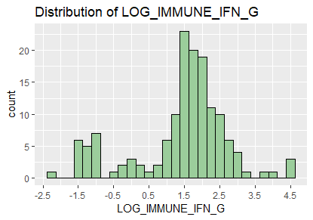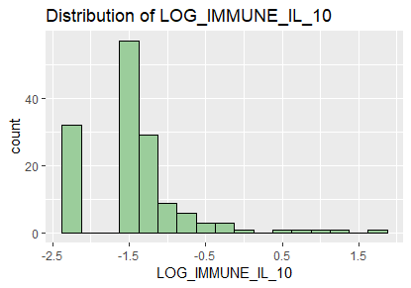

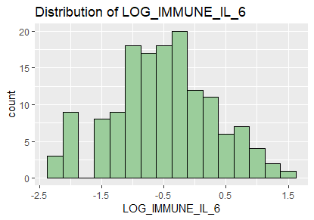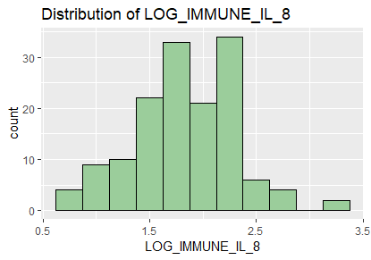

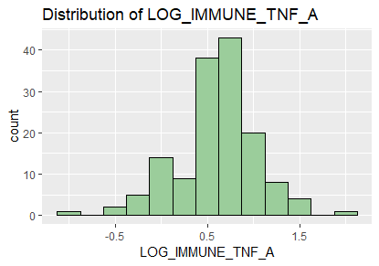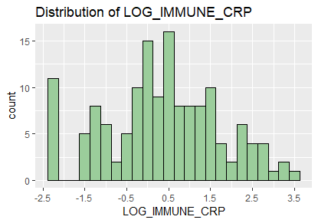

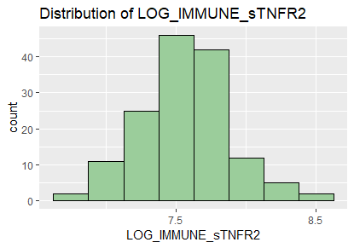

**Multivariate Logistic Regression Model**

|  |  |  |  |  |  |
| --- | --- | --- | --- | --- | --- |
| **Using all inflammatory markers (AIC = 175.41)** | | | **Using inflammatory marker score (173.37)** | | |
|  | Coefficient Estimate | p-value |  | Coefficient Estimate | p-value |
| (Intercept) | -4.8 | 0.61 | (Intercept) | 1.0 | 0.70 |
| AGE_BL | 0.00095 | 0.98 | AGE_BL | -0.010 | 0.74 |
| BMI - underweight | 3.7 | 0.013* | BMI - underweight | 2.1 | 0.10 |
| BMI - overweight | 0.032 | 0.96 | BMI - overweight | 0.066 | 0.92 |
| BMI - obese | -0.86 | 0.36 | BMI - obese | -0.57 | 0.47 |
| SF-vitality score (dichotomous) - baseline | 2.8 | 0.00082*** | SF-vitality score (dichotomous) - baseline | 2.0 | 0.0023** |
| white | -0.44 | 0.55 | white | -0.021 | 0.97 |
| Edu - At most a high school degree | -1.6 | 0.045* | Edu - At most a high school degree | -1.2 | 0.082 |
| Edu - College graduate | -0.58 | 0.43668 | Edu - College graduate | -0.70 | 0.25 |
| Employed | -1.6 | 0.015* | Employed | -1.3 | 0.034* |
| MARRIED | -0.20 | 0.76 | MARRIED | -0.34 | 0.57 |
| Mastectomy | 1.0 | 0.27 | Mastectomy | 0.87 | 0.30 |
| Chemo only | -1.6 | 0.13 | Chemo only | -1.1 | 0.25 |
| Radiation only | 0.36 | 0.65 | Radiation only | 0.035 | 0.96 |
| Charlson | 1.2 | 0.024* | Charlson | 0.90 | 0.051 |
| Ctq - Any childhood maltreatment | -0.014 | 0.98 | Ctq - Any childhood maltreatment | -0.15 | 0.78 |
| Prior history of depression | 0.62 | 0.39 | Prior history of depression | 0.27 | 0.68 |
| IES_BL | 0.27 | 0.38 | IES_BL | 0.024 | 0.93 |
| FCS_BL | -0.28 | 0.73 | FCS_BL | -0.11 | 0.88 |
| PSS_BL | -0.030 | 0.65 | PSS_BL | -0.020 | 0.73 |
| PSQI_BL | 0.11 | 0.25 | PSQI_BL | 0.14 | 0.12 |
| CESD_BL | 0.062 | 0.28 | CESD_BL | 0.083 | 0.12 |
| SPS Attachment – Max | -0.69 | 0.31 | SPS Attachment – Max | -0.18 | 0.76 |
| tnf_2cat | -1.8 | 0.0097** | tnf_2cat | -1.3 | 0.034* |
| il6_2cat | -0.68 | 0.26 | il6_2cat | -0.33 | 0.55 |
| il1b_2cat | -0.78 | 0.49 | il1b_2cat | -0.41 | 0.66 |
| LOG_IMMUNE_IFN_G | 0.40 | 0.23 | Inflammatory marker score | -0.0050 | 0.95 |
| LOG_IMMUNE_IL_10 | -0.37 | 0.35 |
| LOG_IMMUNE_IL_6 | -1.1 | 0.054 |
| LOG_IMMUNE_IL_8 | 0.87 | 0.22 |
| LOG_IMMUNE_TNF_A | -1.4 | 0.24 |
| LOG_IMMUNE_CRP | 0.71 | 0.018* |
| LOG_IMMUNE_sTNFR2 | 0.51 | 0.69 |

Note: 51 objects were deleted due to missing values, leaving a total sample size of 142 for this model.

**Individual multivariate logistic regression model with an immune marker one at a time**

|  |  |  |
| --- | --- | --- |
|  | **Coefficient Estimate** | **p-value** |
| LOG_IMMUNE_IFN_G | -0.049 | 0.82 |
| LOG_IMMUNE_IL_10 | -0.18 | 0.61 |
| LOG_IMMUNE_IL_6 | -0.32 | 0.40 |
| LOG_IMMUNE_IL_8 | 0.52 | 0.37 |
| LOG_IMMUNE_TNF_A | -0.62 | 0.43 |
| LOG_IMMUNE_CRP | 0.40 | 0.077 |
| LOG_IMMUNE_sTNFR2 | -0.66 | 0.51 |

**Correlation Matrix for Immune Markers**

|  |  |  |  |  |  |  |  |
| --- | --- | --- | --- | --- | --- | --- | --- |
|  | LOG_IMMUNE_IFN_G | LOG_IMMUNE_IL_10 | LOG_IMMUNE_IL_6 | LOG_IMMUNE_IL_8 | LOG_IMMUNE_TNF_A | LOG_IMMUNE_CRP | LOG_IMMUNE_sTNFR2 |
| LOG_IMMUNE_IFN_G | 1 | 0 | 0.46 | 0.18 | 0.62 | -0.04 | 0.38 |
| LOG_IMMUNE_IL_10 | 0 | 1 | 0.07 | 0.07 | 0.04 | 0.18 | 0.19 |
| LOG_IMMUNE_IL_6 | 0.46 | 0.07 | 1 | 0.17 | 0.5 | 0.48 | 0.49 |
| LOG_IMMUNE_IL_8 | 0.18 | 0.07 | 0.17 | 1 | 0.37 | 0.1 | 0.17 |
| LOG_IMMUNE_TNF_A | 0.62 | 0.04 | 0.5 | 0.37 | 1 | 0.11 | 0.62 |
| LOG_IMMUNE_CRP | -0.04 | 0.18 | 0.48 | 0.1 | 0.11 | 1 | 0.19 |
| LOG_IMMUNE_sTNFR2 | 0.38 | 0.19 | 0.49 | 0.17 | 0.62 | 0.19 | 1 |

**Principal Component Analysis for Immune Markers**

* Importance of components:

|  |  |  |  |  |  |  |  |
| --- | --- | --- | --- | --- | --- | --- | --- |
|  | PC1 | PC2 | PC3 | PC4 | PC5 | PC6 | PC7 |
| Standard deviation | 1.7 | 1.1 | 0.97 | 0.94 | 0.75 | 0.57 | 0.50 |
| Proportion of Variance | 0.40 | 0.18 | 0.14 | 0.13 | 0.081 | 0.047 | 0.036 |
| Cumulative Proportion | 0.40 | 0.58 | 0.72 | 0.85 | 0.93 | 0.97 | 1 |

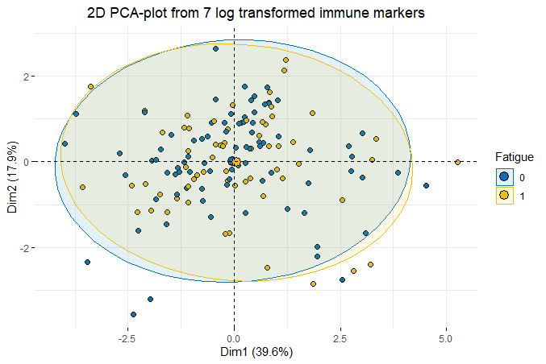

**Figure**: Plot of the first two principal components from the 7 Log transformed immune markers with label of outcome variable (fatigue or not)

**ANOVA p-values for Immune Markers vs. SNPs**

|  |  |  |  |
| --- | --- | --- | --- |
|  | tnf_2cat | il6_2cat | il1b_2cat |
| LOG_IMMUNE_IFN_G | 0.96 | 0.15 | 0.90 |
| LOG_IMMUNE_IL_10 | 0.082 | 0.64 | 0.68 |
| LOG_IMMUNE_IL_6 | 0.20 | 0.17 | 0.091 |
| LOG_IMMUNE_IL_8 | 0.66 | 0.54 | 0.30 |
| LOG_IMMUNE_TNF_A | 0.35 | 0.22 | 0.24 |
| LOG_IMMUNE_CRP | 0.27 | 0.879 | 0.22 |
| LOG_IMMUNE_sTNFR2 | 0.43 | 0.039* | 0.097 |
| Inflammatory marker score | 0.65 | 0.15 | 0.32 |

**Variable Selection using Stepwise AIC**

* Model 1: Select only SNPs and immune markers & keep all other variables (**AIC = 169.07**)

|  |  |  |
| --- | --- | --- |
|  | **Coefficient Estimate** | **p-value** |
| (Intercept) | 1.1 | 0.68 |
| AGE_BL | -0.0070 | 0.81 |
| BMI - underweight | 3.2 | 0.024* |
| BMI - overweight | 0.066 | 0.92 |
| BMI - obese | -0.87 | 0.33 |
| SF-vitality score (dichotomous) -baseline | 2.5 | 0.00084*** |
| white | -0.41 | 0.55 |
| Edu - At most a high school degree | -1.7 | 0.029* |
| Edu - College graduate | -0.99 | 0.14 |
| Employed | -1.6 | 0.013* |
| MARRIED | -0.19 | 0.76 |
| Mastectomy | 0.84 | 0.31 |
| Chemo only | -1.0 | 0.30 |
| Radiation only | 0.51 | 0.47 |
| Charlson | 1.02 | 0.041* |
| Ctq - Any childhood maltreatment | -0.085 | 0.88 |
| Prior history of depression | 0.59 | 0.39 |
| IES_BL | 0.17 | 0.54 |
| FCS_BL | -0.081 | 0.92 |
| PSS_BL | -0.031 | 0.62 |
| PSQI_BL | 0.12 | 0.19 |
| CESD_BL | 0.071 | 0.18 |
| SPS Attachment – Max | -0.29 | 0.64 |
| tnf_2cat | -1.7 | 0.014* |
| il6_2cat | -0.63 | 0.27 |
| il1b_2cat | -0.60 | 0.56 |
| LOG_IMMUNE_IL_6 | -0.75 | 0.089 |
| LOG_IMMUNE_CRP | 0.60 | 0.026* |

* Model 2: Overall model selection (**AIC = 148.6**)

|  |  |  |
| --- | --- | --- |
|  | **Coefficient Estimate** | **p-value** |
| (Intercept) | -0.71 | 0.42 |
| BMI - underweight | 2.7 | 0.032* |
| BMI - overweight | 0.16 | 0.79 |
| BMI - obese | -0.42 | 0.59 |
| SF-vitality score (dichotomous) | 2.1 | 0.00031*** |
| Edu - At most a high school degree | -1.4 | 0.037* |
| Edu - College graduate | -0.92 | 0.11 |
| Employed | -1.5 | 0.0073** |
| Charlson | 0.90 | 0.037* |
| PSQI_BL | 0.11 | 0.16 |
| CESD_BL | 0.079 | 0.037* |
| tnf_2cat | -1.5 | 0.013* |
| LOG_IMMUNE_IL_6 | -0.59 | 0.11 |
| LOG_IMMUNE_CRP | 0.43 | 0.052 |